INTRODUCTION

Since the inception of the theory and idea of development, the common feature that emerged in different point of time is the developmental gap that emerged in different parts of the world and also among various parts of a country in a particular time period. This disparity in development, theories believed that agriculture, industrialisation, urbanisation, are significant ingredients of growth, and, ultimately important prerequisites for achieving development. Within the economy itself, the status of growth of a state can be judged through its performance in agricultural and industrial production, performance of service sector and urbanisation, and their impact through their contribution in income and employment generation at the national level. Thus, house price behaviour may also reflect some short of developmental status of the households of a country. Keeping in view the above fact of rapid urbanisation and regional disparities, it is not unexpected that it may lead to some sort of differences in regional house prices, where housing and real estate are considered as major sources of physical and financial asset. This also leads to the differences in the dynamics of house price determination.

PROBLEM DEFINITION & DESIGN THINKING

Empathy Map

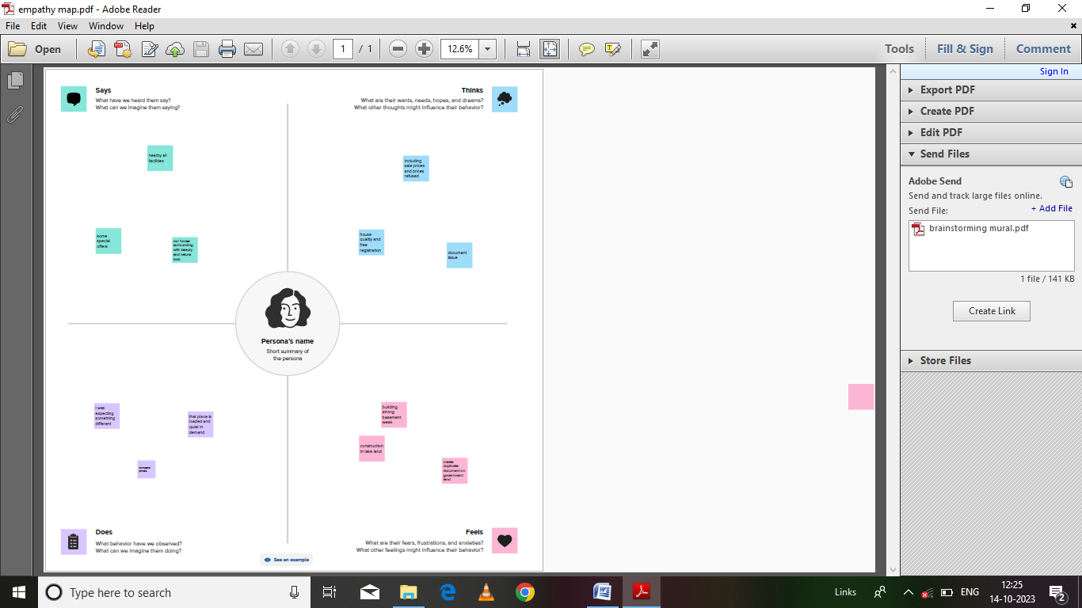

Ideation & Brainstorming Map

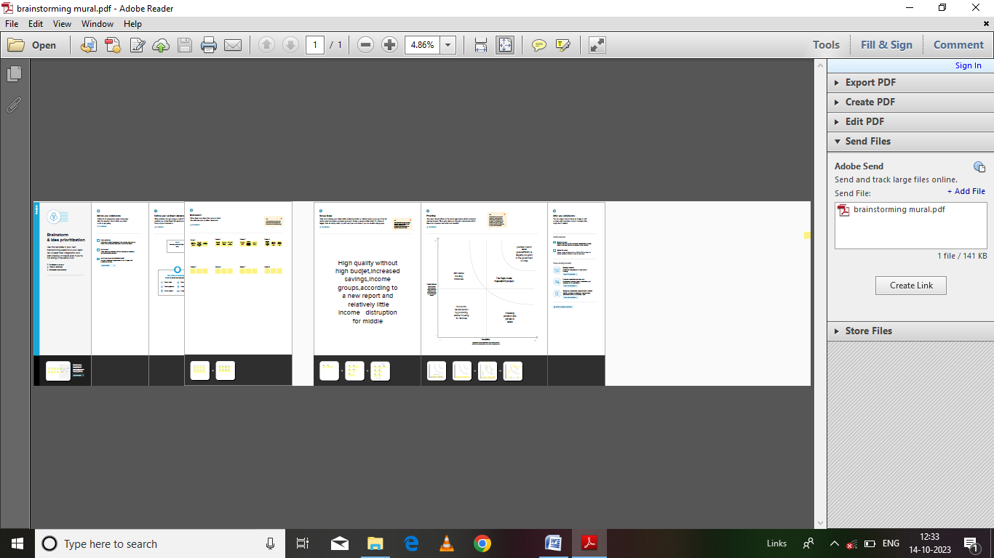

RESULT

The result of the Im, pesaran and shin panel unit root test is presented The consistently high probabilities of the relative house prices indicate that the series is consistently non-stationary and therefore diverges indefinitely in the long-run. The lack of convergence of the relative house prices simply implies that separate metropolitan cities in India function as separate housing markets in their respective localities. In other words, the law of One Price (Loop) does not hold in Indian housing market case.

ADVANTAGES

Housing prices in india have surged during the first quarter of 2023 with the average price rise across all the major realty markets being close to 7% YoY, according to report by PropTiger.com. the report said all the markets covered in the analysis showed an upward movement in average rates of new homes.

DISADVANTAGES

High cost of rent and food

Overpopulation and pollution

Increased competition and societal callousness

APPLICATIONS

One of the most significant solutions is the government policies and initiatives. The PRADHAN MANTRI AWAS YOJANA (PMAY) is a flagship program of the government of India, aimed at providing affordable housing for all by 2022.

CONCLUSION

This paper analyzes whether the law of one price (LOOP) holds in the housing market of fifteen metropolitan areas in India, namely Delhi, Mumbai, Bengaluru, Kolkata, Chennai, Jaipur, Lucknow, Hyderabad, Pune, Surat, Ahmedabad, Patna, Faridabad, Kochi and Bhopal.

FUTURE SCOPE

In 2021, the size of the Indian property market was $200 billion, and there is a projection that it will achieve $1 trillion by 2030. Furthermore, the real estate sector is anticipated to contribute 13 percent to the total GDP of the country by 2025.

SHEET1

SHEET2 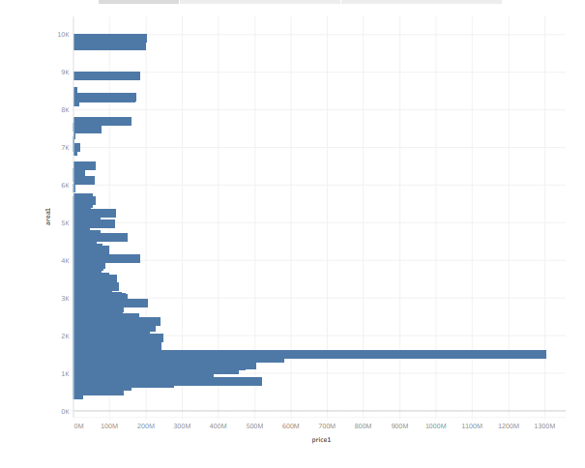

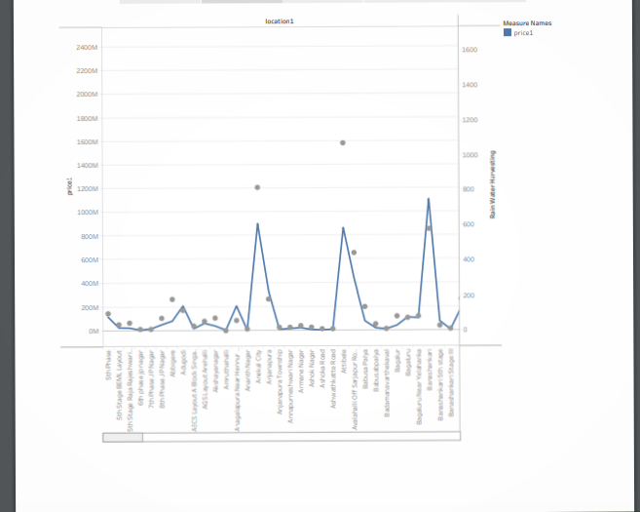

SHEEET 3

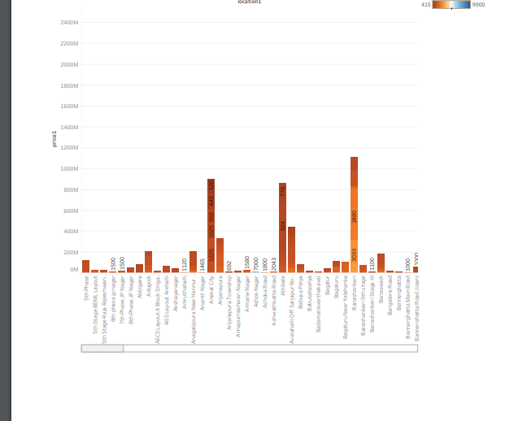

SHEET 4

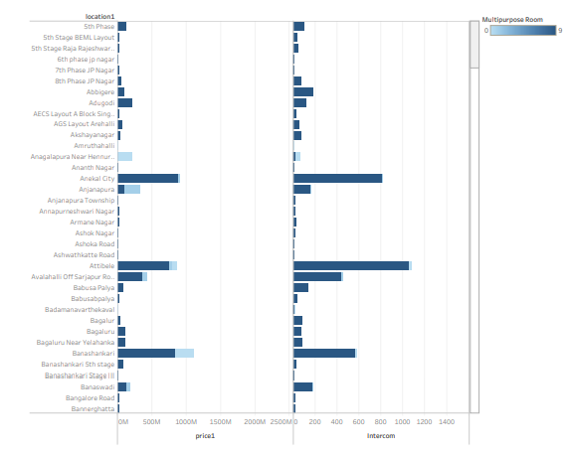

SHEET5